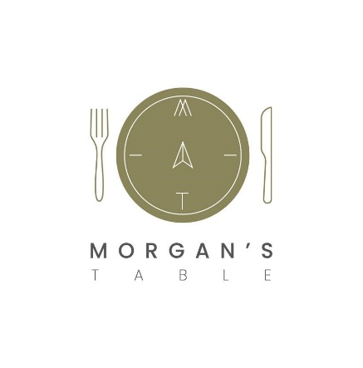
Morgan’s Table

BUFFET MENU

£7.00 per head
A platter of freshly prepared sandwiches on white or wholemeal bread.
A platter of freshly prepared white and wholemeal wraps
A selection of party sized cocktail sausages, cocktail pasties
A selection of quiche, mini pork pies and mini scotch eggs
Chicken goujons

£9.00 per head
A platter of freshly prepared sandwiches on white or wholemeal bread.
A platter of freshly prepared white and wholemeal wraps
A selection of party sized cocktail sausages, cocktail pasties
A selection of quiche, mini pork pies and mini scotch eggs
Selection of mini vegetable spring rolls, mini vegetable samosas
Mini onion bhajis,
Chicken goujons

£12.00 per head
A platter of freshly prepared sandwiches on white or wholemeal bread
A platter of freshly prepared white and wholemeal wraps
A selection of party sized cocktail sausages, cocktail pasties
A selection of quiche, mini pork pies and mini scotch eggs
Corned beef cutting pie, Cornish cutting pie and gala pie
Selection of mini vegetable spring rolls, mini vegetable samosas
Mini onion bhajis
A selection of hot BBQ, Chinese and Tandoori marinated chicken skewers and drumsticks with a selection of dips

£14.00 per head
A platter of freshly prepared sandwiches on white or wholemeal bread
A platter of freshly prepared white and wholemeal wraps
A selection of party sized cocktail sausages, cocktail pasties
A selection of quiche, mini pork pies and mini scotch eggs
Selection of corned beef cutting pie, Cornish cutting pie and gala pie
Selection of mini vegetable spring rolls, mini vegetable samosas
Mini onion bhajis
A selection of hot BBQ, Chinese and Tandoori marinated chicken skewers and drumsticks with a selection of dips
Selection of mini cakes
Cheeseboard with crackers and chutney’s

Unlimited Tea and Coffee £3.00 per person for bookings of 3 hours or less

Unlimited Tea and Coffee £5.00 per person for bookings over 3 hours

A platter of Fresh Fruit is available for £20

Name

Date of Function

Preferred method of payment
Eg Card, Cash, Invoice

Purchase Order Number if applicable

Buffet Option? £7 £9 £12 £14
Number of people

Time of Buffet

Tea/Coffee/Water? y/n
Frequency of Tea/Coffee? Eg 3 servings per day?
Fruit Platter? y/n
Special dietary requirements.
Please inform us of any dietary requirements.

Total

Payment: A non-refundable deposit of £50 (or 20% if less than £50) must be made at the time of booking. If less than a months’ notice is given full payment must be made at the time of booking. If paying by invoice the total must be cleared within 2 weeks of the function commencement date. We require at least 1 weeks’ notice on all bookings
Cancellation: We require a weeks’ notice on all cancellations. This does not include the non-refundable deposit. For any cancellations less than a week old you will be charged the full amount.as a refund cannot be given.

By singing this form I Acknowledge agreement to the above terms and conditions:

Name ________________________________________________ Date_____________

